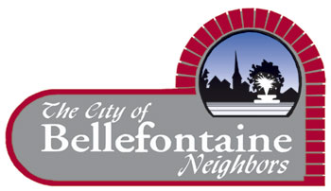
Position Description
Front Desk

Position: Front Desk
Reports to: Recreation Supervisor
Salary Range: $10.30-11.30 per hour
Dates of employment: year round or seasonal
Job Summary:
Responsible for the daily operations at the front desk, specifically selling memberships, program registration, checking in members and guests, answering the telephone, and issuing equipment. Front Desk duties also includes cleaning, vacuuming, dusting and general cleanliness of the internal and external areas of the front desk and lobby. This also includes any other duties deemed necessary to perform the job.
Essential Job Functions:
- Ability to operate computer, cash draw, credit card machine and multi-line telephone
- Must be able to work with the general public in a professional manner
- Must be able to handle multiple tasks at once
- Disseminate information about programs, special events, facility memberships, admission rates and policies in a polite and effective manner
- Answer the telephone in a professional manner and relay calls to appropriate people
- Enforcement of building policies, rules and regulations
- Computer data entry and other front desk paperwork
Knowledge, Skills and Abilities Required:
- Previous cash handling skills
- Knowledge of general cashier practices and procedures
- Ability to work with the general public in a professional manner
- Ability to work independently and efficiently without routing supervision
- Maintain a positive self image for the City and the department
- Ability to work with frequent interruptions and during periods of high volume and under pressure from the public
- Ability to establish and maintain effective working relationships with departmental staff, other city staff and the general public
- Ability to communicate effectively in oral and written form
Education, Qualifications and Experience Required:
- Must be at least 18 years of age
- Must be able to work days, evenings and weekends
- Possess and demonstrate the skills to accurately handle multiple priorities, tasks, problems and situations
You may apply online www.cityofbn.com/administration/job-openings, or resumes and applications may also be mailed or dropped off at the Bellefontaine Neighbors Recreation Center, 9669 Bellefontaine Road, Bellefontaine Neighbors, MO 63137. Interested applicants may also send a completed application to Amy Mulholland @ amulholland@cityofbn.com.

